Task 2: Requirement Elicitations

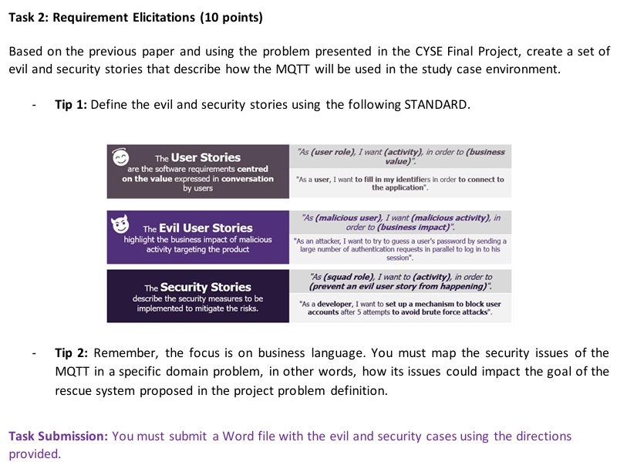

|  |  |
| --- | --- |
| **Evil User Stories** | **Security Stories** |
| 1. As an attacker, I want to manipulate MQTT and interrupt the camera controls to disrupt security operations. | 1. As a developer, I want to implement Role based access so only authorised users can perform operations on the camera. |
| 1. As an attacker, I want to alter the MQTT messages in transit to inject malicious commands. | 1. As a developer, I want to implement cryptographic hashing for message Authenticity and Integrity. |
| 1. As an attacker, I want to flood the broker with bogus messages to interrupt the airport surveillance. | 1. As a developer, I want to implement message rate, exciding a minimum message rate for a given time disconnects the user. |
| 1. As an attacker, I want to Custom webpage for XSS attack and Session Hijacking. | 1. As a developer, I want to implement sanitisation of User inputs to block scripts as Input. |